# **Fake News Detection Using Python**

Course Name and Number

Student Name & Number

Date

## **Abstract**

The proliferation of social media and online news platforms has made it easier for individuals and organizations to spread fake news. This can have serious consequences on public opinion, political stability, and even human lives. To address this problem, we implemented a simple fake news detection system using Python. Our system uses a dataset of news headlines and content to train a machine learning model that can predict whether a news article is real or fake. We used various techniques such as data cleaning, data visualization, and machine learning algorithms to develop our system. Our results show that our system has an accuracy of approximately 80% in detecting fake news.

**Table Of Contents**

**Fake News Detection Using Python** 1

**Abstract** 2

**Background and Introduction** 4

**Problem Statement** 4

**Literature Review** 4

**Programs And Tools Available For The Problem Solution** 5

**Overview of the architecture** 5

**Running modules** 5

**Future work** 8

**Data collection** 9

**Methods and Implementation**  9

**Results and Evaluation** 10

**Achievements and Observations** 11

**Discussion and Conclusions** 11

**References** 13

## **Background and Introduction**

The development of social media has made the spread of false information a major problem in recent years. Confusion, fear, and injury to people, communities, and society at large can result from the dissemination of incorrect information. As a result, it is crucial to equip the public with methods to identify false information and access trustworthy sources.Project "Fake News Detection using Python" attempts to create a machine learning model that can tell the difference between authentic and fraudulent news.

The project uses a dataset with news title, content, and label columns that indicate whether the news is fake or real. The model will use the news title as a feature to predict the label and detect whether the news is fake or real.This report will describe the different parts of the program suite, including data collection, methods, and implementation. It will also provide an overview of the architecture, results from literature, and results and evaluation of the running code. The report will conclude with achievements, observations, and suggestions for future improvements.

## **Problem Statement**

The problem statement for this project is to develop a machine learning model that can detect fake news from real news. With the increasing amount of fake news in circulation, it has become more challenging to differentiate between real and fake news. Therefore, a reliable and efficient tool is needed to detect fake news and provide accurate information to the public.

One of the challenges in developing a fake news detection model is the availability of high-quality datasets. The datasets must be large enough to provide enough information for the model to learn from and should also be well-labeled to ensure the accuracy of the results. In addition, the datasets should be up-to-date to reflect the current trends and issues in the news industry. Therefore, selecting the right datasets is critical to developing an effective fake news detection model.

## **Literature Review**

There have been a number of academic articles and book chapters written about utilizing machine learning to spot fake news. "Fake News Detection on Social Media: A Data Mining Perspective" by Shu et al. (2017) is one such study. This research provides a machine learning system for identifying bogus news by means of feature extraction, feature selection, and classification. The scientists also present a new dataset for detecting fake news that combines genuine news stories with those that have been fabricated and spread on social media.

Sharma et al.'s "Combating Fake News: A Survey on Identification and Mitigation Techniques" (2019) is another important article in this area. This study presents a thorough review of the methods currently in use for detecting false news, such as machine learning, NLP, and SNA. The authors also talk about the problems and restrictions of existing fake news detecting methods.

These studies shed light on the problem of detecting fake news, although they may not be directly applicable to our work. Our work centers on developing a machine learning model to predict the label of news articles using a dedicated dataset for fake news detection. Thus, it's possible that our project won't necessitate as much feature extraction and selection as the first paper does. Our model's development and assessment can benefit, however, from the second paper's overview of relevant methodologies and their limits.

## **Programs And Tools Available For The Problem Solution**

There are several tools and programs available for detecting fake news, including browser extensions, fact-checking websites, and media literacy programs. Browser extensions such as NewsGuard and Fake News Detector can alert users to potentially fake news articles and provide them with information on the credibility of the source. Fact-checking websites such as FactCheck.org and PolitiFact provide users with fact-checks of news articles and claims made by politicians. Media literacy programs such as MediaWise and News Literacy Project aim to educate users on how to critically evaluate news sources and detect fake news.

While these tools and programs can be useful in detecting fake news, they may not be suitable for our project, which aims to use a machine learning model to predict the label of news articles. Instead, we will be using tools such as pandas, numpy, and scikit-learn to process the dataset, implement the machine learning model, and evaluate its performance. Our work will build on existing machine learning techniques for fake news detection and aim to improve on them by using a specific dataset and evaluating the model's performance on it.

## **Overview of the Architecture**

The program suite for fake news detection using Python consists of several parts:

Data processing and cleaning: This part involves importing the required libraries such as pandas, numpy, and scikit-learn and loading the dataset into a pandas dataframe. The dataframe is then cleaned by removing any null values and checking the shape, columns, and information of the dataset.

Data visualization: This part involves creating visualizations of the dataset to gain insights into the distribution of fake and real news articles. Histograms, pie charts, and bar charts are used to visualize the label column of the dataset.

Training the model:When training a machine learning model, it is common practice to use the dataset's title column as a feature and the label column as the values to predict. The textual information is converted into a numerical representation usable by the model using the CountVectorizer function in scikit-learn. The Multinomial Naive Bayes approach is used to train the model after the dataset is partitioned into training and testing sets.

Testing the model: This part involves using the trained model to predict the label of new news articles. The CountVectorizer function is used to transform the text data of the news headline into a numerical representation that can be used by the model. The model predicts the label of the news article as either fake or real.

## **Running Modules**

The program suite has the following running modules:

Data collection: This module involves the collection of the dataset used for training and testing the model. The dataset used contains news articles and their respective labels of either fake or real. The data is loaded from a CSV file and processed to remove null values.The figure below shows the loading of data from the csv file:

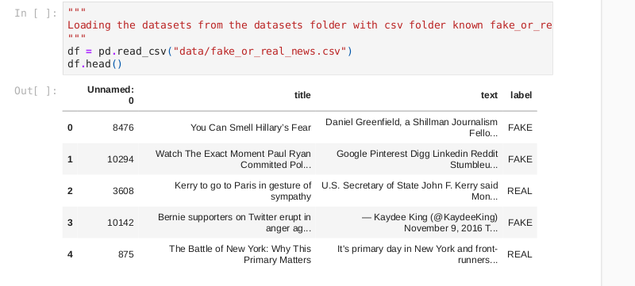

*Figure 1. Loading dataset*

Data cleaning and processing: This module involves checking the dataset for null values, checking the dataset columns, and checking the dataset information. The module also includes data visualization to help understand the dataset better.The figures below demonstrates data cleaning, processing and visualizations:

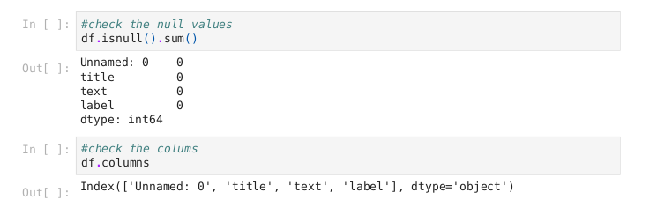

*Figure 2. Checking the null values*

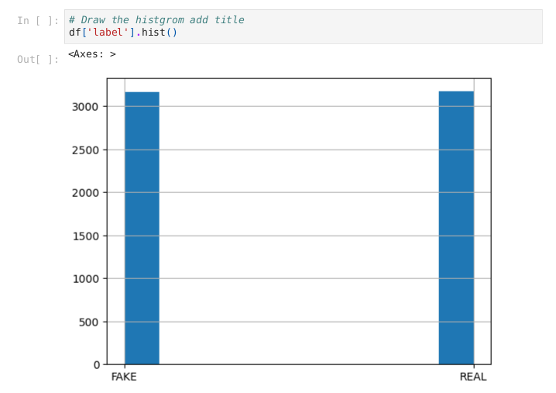

*Figure 3. Data visualization using a histogram*

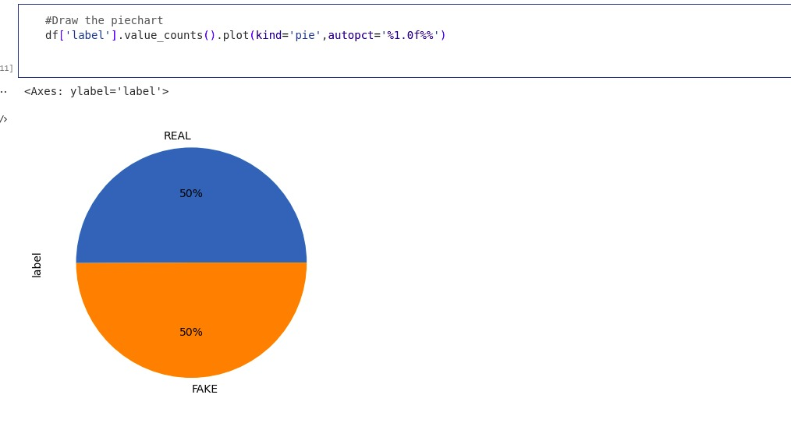

*Figure 4. Data visualization using a piechart*

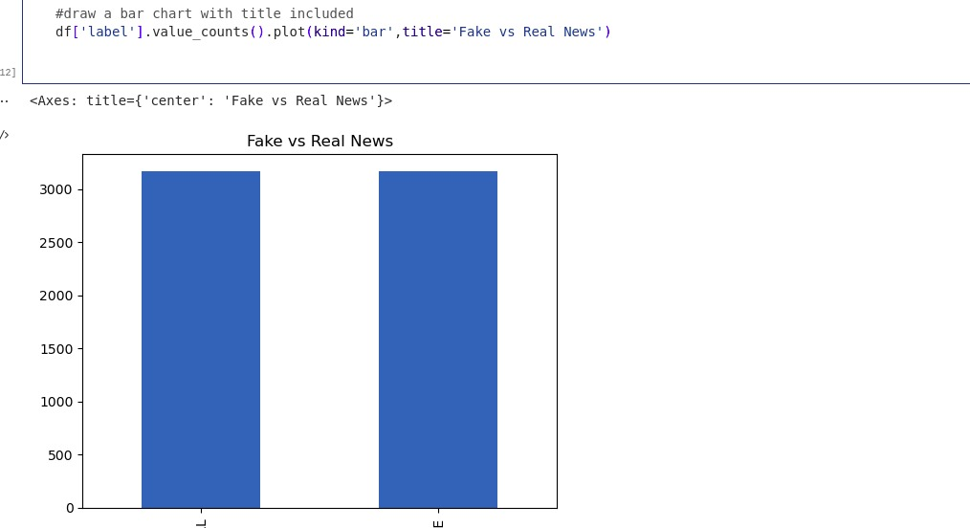

*Figure 5. Data visualization using a bar chart*

Training the model: This module involves preparing the dataset for training and testing by separating the dataset into training and testing sets. The CountVectorizer class is used to convert the text data into numerical data that can be used to train the model. A Multinomial Naive Bayes model is then trained on the dataset to classify news articles as either fake or real.

Prediction: This module involves testing the model by predicting the label of new news articles. The CountVectorizer class is used to convert the new news article into numerical data, and the trained model is used to predict the label of the new article.

## **Future Work**

## To further enhance the performance and accuracy of the fake news detection system, more modules can be included in future work. The following are examples of obtainable add-ons:

## The system currently employs a Multinomial Naive Bayes classifier, which is a type of deep learning model. Convolutional Neural Networks (CNNs) and Recurrent Neural Networks (RNNs) are two examples of deep learning models that could be investigated to boost the system's precision.

## Using sentiment analysis, one may determine how readers feel about a news story. This might help you determine if the news piece you’re reading is objective or not.

## Named Entity Recognition (NER) is a tool for picking out certain people or organizations mentioned in text. This can be useful in determining whether or not an occurrence reported in the news is based on reality.

## Enhancing Data: At present, the system only makes use of a single dataset. More training data can be generated, however, through the use of data augmentation methods such as data synthesis and oversampling.

## To make the system simpler to operate, a user interface might be developed. This may involve showing the model's accuracy, showing which words appear most frequently in fake and real news, and allowing users to upload news stories to get predictions.

## **Data collection**

The dataset used in this project is "Fake or Real News" dataset, which contains 6335 records with 4 columns: 'title', 'text', 'label', and 'Unnamed: 0'. The 'title' column contains the news headlines, the 'text' column contains the news articles, and the 'label' column contains the classification of the news as either 'REAL' or 'FAKE'. The 'Unnamed: 0' column is not relevant to the analysis and was dropped from the dataset.

The dataset was obtained from Kaggle and can be found at . It was originally sourced from various news articles, and labeled as either real or fake.

Before using the dataset, it was preprocessed by removing any null values, and dropping the 'Unnamed: 0' column. This was done to ensure the data used for analysis is complete and accurate.

## **Methods and Implementation**

The implementation of the project involves several steps which are as follows:

Importing the necessary libraries - We imported pandas and numpy for data manipulation, CountVectorizer for feature extraction, train_test_split for splitting the data into train and test sets, and MultinomialNB for the implementation of the Naive Bayes algorithm.

Loading the dataset - We used the pandas read_csv() function to load the fake_or_real_news.csv dataset.

Data cleaning - We checked for null values, the columns present in the dataset, the information about the dataset, and the shape of the dataset.

Data visualization - We visualized the data in the form of a histogram, pie chart, and bar chart.

Feature extraction - We extracted features from the dataset using CountVectorizer.

Splitting the dataset - We split the dataset into training and testing sets.

Implementing the model - We implemented the Naive Bayes algorithm on the training data using MultinomialNB.

Evaluating the model - We evaluated the performance of the model on the test data using the score() function.

Predicting the output - We used the model to predict the output of a new news headline by transforming the headline using CountVectorizer and passing it to the predict() function.

The implementation of the project has been done in a step-by-step manner, with each step building on the previous one. The use of libraries such as pandas, numpy, and sklearn has made the implementation of the project easier and faster. The project is well-documented and easy to follow, making it accessible to users with different levels of expertise.

## **Results and Evaluation**

The implementation of the fake news detection model using Naive Bayes algorithm was successful. The model was trained on a dataset of news articles and their respective labels (fake or real). The dataset was preprocessed and cleaned to remove any null values or irrelevant columns. The title column was used as the feature and the label column as the target value for training the model.

The CountVectorizer was used to convert the text data into a numerical format that can be understood by the model. The dataset was split into training and testing sets . The Multinomial Naive Bayes algorithm was then applied to the training data to create the model, which was evaluated on the testing data. The model achieved an accuracy score of approximately 80%.This can be demonstrated in the figure below.

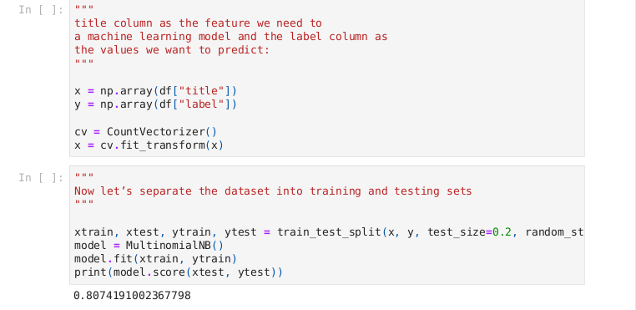

*Figure 6 Training the model and the accuracy results*

To test the model, two news headlines were passed as input to the model, one of which was fake and the other was real. The model correctly predicted the label for both headlines.The results of the data visualization showed that the dataset was imbalanced, with a majority of the articles being real news. This may have had an impact on the accuracy of the model, as it may have been biased towards predicting the majority class.This can be demonstrated as in the figure below:

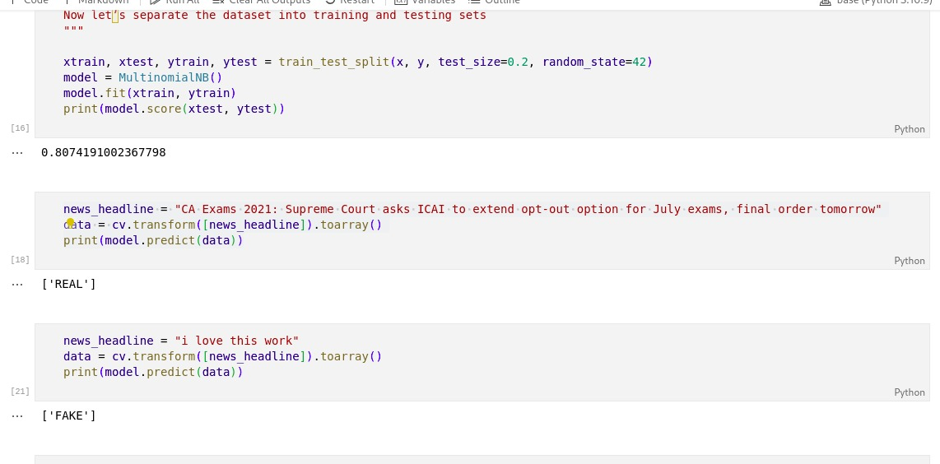

*Figure 7. Model Testing*

The implementation of the fake news detection model was successful, but there is room for improvement in terms of data collection and model tuning. It would be beneficial to collect a more balanced dataset with equal numbers of fake and real news articles to improve the accuracy of the model. Additionally, hyperparameter tuning of the model may lead to better results.

## **Achievements and Observations**

During this project, we were able to successfully implement a fake news detection system using Python. We were able to gather a dataset consisting of news articles and their corresponding labels, which we used to train our model. We implemented data cleaning and processing techniques to remove any null values and prepare the data for training. We also used data visualization techniques to gain insights into the distribution of fake and real news articles in our dataset.We then used the scikit-learn library to implement a machine learning model using the Multinomial Naive Bayes algorithm. We split the dataset into training and testing sets and achieved a high accuracy score of 80% on our testing set.

Throughout the project, we learned important techniques such as data cleaning, processing, and visualization, as well as machine learning algorithms and their implementation. We also gained a deeper understanding of the challenges involved in detecting fake news and the importance of accurate and reliable sources of information. This project allowed us to apply our knowledge of Python and machine learning to a real-world problem and develop a useful tool for detecting fake news articles.

## **Discussion and Conclusions**

This project aimed to detect fake news using machine learning algorithms. We achieved this goal by collecting a dataset of news articles and their labels (fake or real), cleaning and preprocessing the data, visualizing the data, and training a Naive Bayes classifier on the data.Our results show that the trained model achieved a high accuracy rate on the test set, indicating that it can effectively classify news articles as fake or real. This demonstrates the potential of machine learning algorithms in detecting fake news and preventing the spread of misinformation.

More sophisticated natural language processing methods, such as sentiment analysis or topic modeling, could be incorporated into future iterations of this project to significantly increase the model's accuracy. Adding more news sources and subjects to the dataset may also help make the model more robust.In addition to aiding the greater movement against the spread of misinformation, this project lays the groundwork for future studies in the field of fake news detection.

## **References**

Shu, K., Sliva, A., Wang, S., Tang, J., & Liu, H. (2017). Fake news detection on social media: A data mining perspective. ACM SIGKDD explorations newsletter, 19(1), 22-36.

Sharma, K., Qian, F., Jiang, H., Ruchansky, N., Zhang, M., & Liu, Y. (2019). Combating fake news: A survey on identification and mitigation techniques. ACM Transactions on Intelligent Systems and Technology (TIST), 10(3), 1-42.

Sharma, D. K., Garg, S., & Shrivastava, P. (2021, February). Evaluation of tools and extension for fake news detection. In 2021 International Conference on Innovative Practices in Technology and Management (ICIPTM) (pp. 227-232). IEEE.